HACKATHON DAY 5 TESTING, ERROR

HANDLING, AND BACKEND INTEGRATION REFINEMENT

In our AI-driven clothing platform, we prioritize seamless user experiences by conducting rigorous testing across all functionalities. Our team ensures robust error handling mechanisms are in place to prevent disruptions and provide clear, user-friendly feedback. By continuously refining backend integrations, we enhance the speed, reliability, and accuracy of our platform, ensuring every interaction feels intuitive and efficient. This commitment to excellence allows us to deliver a polished and innovative service tailored to our users' needs.

TESTING:

**Functional Testing**

1. Functional testing ensures that every feature of the website operates according to specified requirements.
2. Each function is tested by providing appropriate input and verifying the output against expected results.
3. It focuses on user-facing elements, ensuring seamless navigation, accurate recommendations, and smooth transactions.
4. This testing validates the core functionality of the platform, ensuring a flawless user experience.

**Performance Testing**

1. Performance testing evaluates the website's speed, scalability, and stability under varying load conditions.
2. It ensures that the platform can handle high traffic, large data volumes, and complex operations without slowing down.
3. By identifying bottlenecks, this testing helps optimize response times and improve overall system efficiency.

**Security Testing**

1. Security testing ensures that the platform is protected against potential threats, vulnerabilities, and unauthorized access.
2. It validates critical aspects such as:
   * **Data Encryption**: Ensuring sensitive information is securely encrypted during storage and transmission.
   * **User Authentication**: Verifying that only authorized users can access the system through secure login mechanisms.
   * **Secure Payment Processing**: Safeguarding financial transactions to prevent fraud and unauthorized access.
3. By addressing these areas, security testing mitigates risks, prevents data breaches, and establishes a safe and trustworthy platform for users.

|  |  |  |  |  |  |  |  |  |  |  |  |  |
| --- | --- | --- | --- | --- | --- | --- | --- | --- | --- | --- | --- | --- |
| 1 | **Test Case ID** | **Test Case Description** | **Test Steps** | **Expected Result** | **Actual Result** | **Status** | **Severity Level** | | | | **Assigned To** | **Remarks** |
| 2 | TC001 | Validate product listing page | Open product page > Verify products | Products displayed correctly | Products displayed correctly | Passed | Low | | | | - | No issues found |
| 3 | TC002 | Test API error handling | Disconnect API > Refresh page | Show fallback UI with error message | Error message shown | Passed | High | | | | - | Handled gracefully |
| 4 | TC003 | Check cart functionality | Add product to cart > Verify cart contents | Cart updates with added product | Cart updates as expected | Passed |  | | High | | - | Works as expected | | |
| 5 | TC004 | Ensure responsiveness on mobile | Resize browser window > Check layout | Layout adjusts properly to screen size | Responsive layout working as intended | Passed | |  | | Medium | - | Test successful | |

## Products From API's Data

"The data is being fetched correctly from the API, and there are no errors in it."

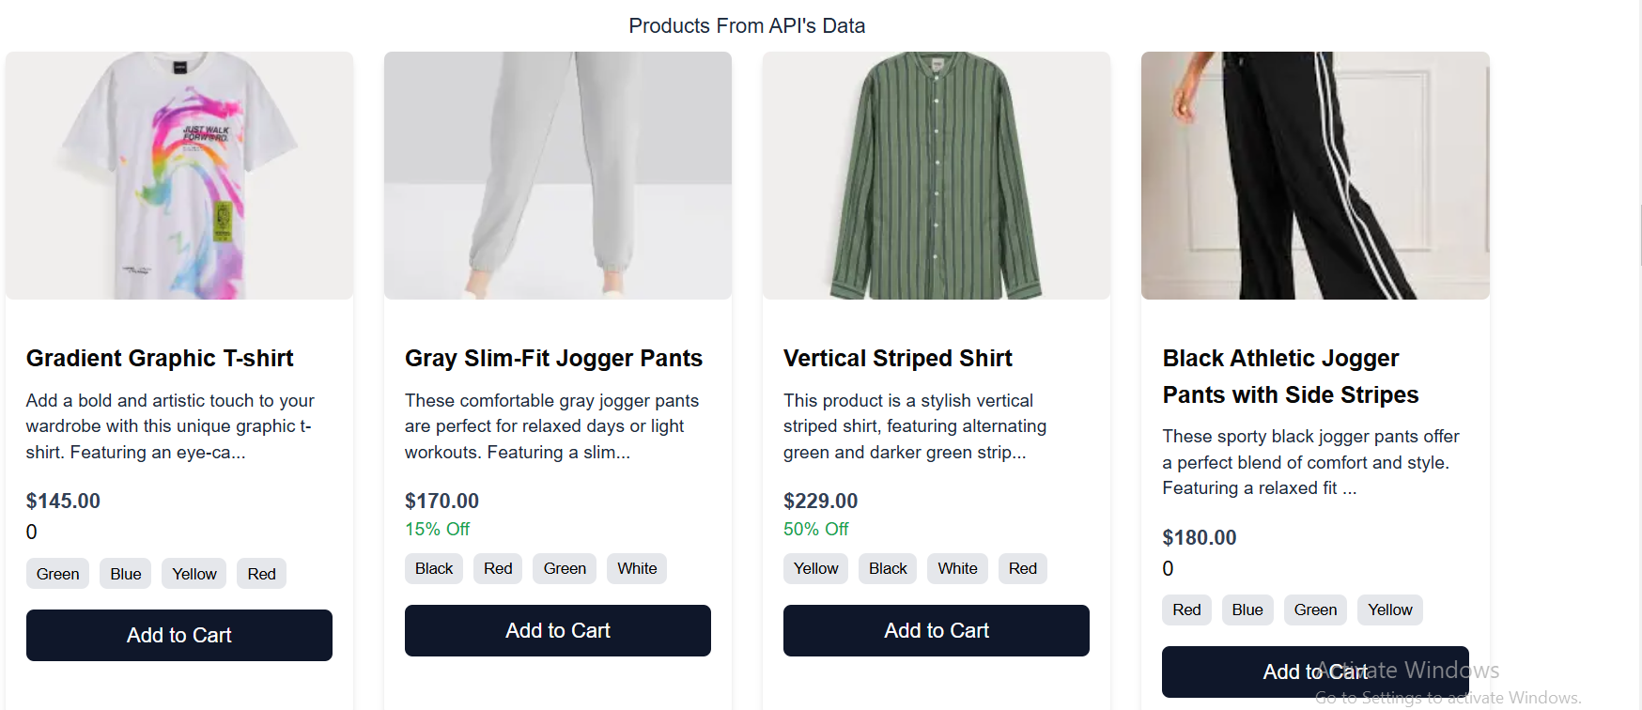

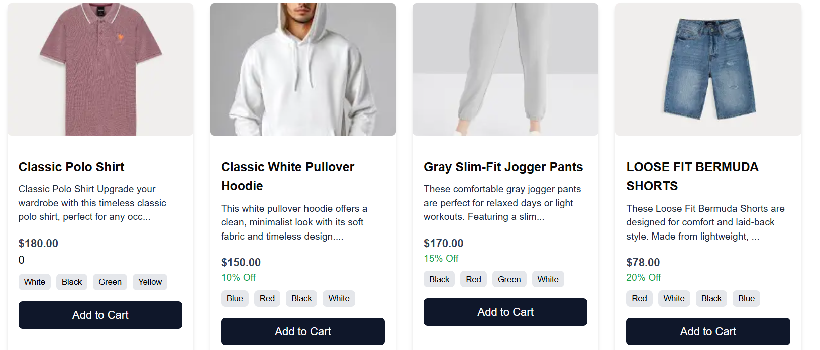

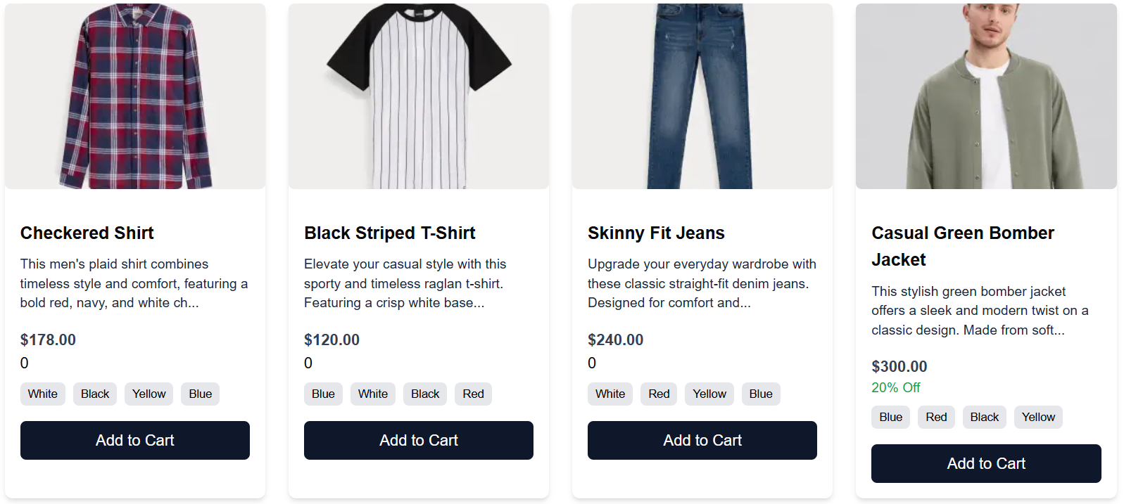

ADD TO CART

